Banding Together: Leadership Learning and Community Support
The Eagles Team Leadership Lab title is “Developing a Foundation of Community Support.” Our mission is to provide the Chicopee High School Band Boosters with ideas and tools to connect with their community in order to build support for the High School Band. Our vision is that our groundwork will provide a foundation enabling and empowering future members of the Chicopee High School Band Boosters to be their most effective in successfully promoting the High School Band and funding its activities and needs for years to come.
Service Provided
We were thrilled to be assigned our top choice of working with the Chicopee High School Band Boosters. We wanted to help them address their stated need of developing a ‘Community Outreach Plan’ to build a foundation of community support, connecting with and engaging alumni, and developing ideas for a signature, annual fundraising event.
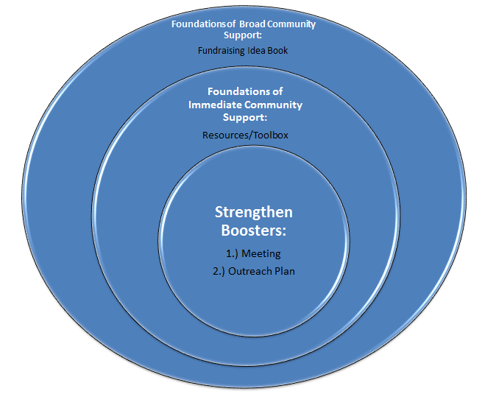
The Eagles were given broad latitude to develop a project in support of the Boosters. After meeting with the Booster parents, we developed a three-pronged approach. We envisioned the project as consisting of three concentric rings with the innermost core being to strengthen the Boosters by helping them identify their mission and determine their key function. The next ring was building a foundation of community support in which we would provide a toolbox of templates to help in outreach efforts around engaging the community, alumni, and volunteers. The last ring was developing broad community support by providing the Boosters with creative ideas around fundraising that they could run with.
In the center ring, we would work to strengthen the Boosters themselves. It became clear to us early on that the Boosters had a great core of dedicated members. This core group has a lot of ideas and a good amount of energy, but it was our impression that they could use help to focus in on a concise mission statement in order to direct their energy in the most effective way. We lead them through two exercises: a SWOT analysis and developing an eight word mission statement.
In the course of the exercise, the Boosters developed the following statement: "to support the band by augmenting existing resources." As with many things we've encountered throughout the Leadership Pioneer Valley experience, it was the process of developing the statement that provided the most benefit. The Boosters were able to engage around important questions such as whether the main focus of the group is to support the band or to advance it; or if they primarily identify new sources of income or augment existing resources available to the band. The outcome implication is that the Boosters will contribute additional resources, in terms of time and financial support, to what the band already has to work with.
We also had the Boosters conduct a SWOT analysis to take an honest look at the strengths, weaknesses, opportunities, and threats of the organization. We encouraged the Boosters to return to the SWOT analysis exercise periodically to help them decide what projects they should undertake and how to approach them.
The second level of our project focused on providing the Boosters with a toolkit of form letters and other resources designed to professionalize their outreach to their immediate community. We created an electronic toolkit where they have "fill in the blank" templates on various tools for community outreach to donors, volunteers, alumni, parents, and others.
The Booster toolkit includes: a welcome email to new band parents requesting support; a welcome email to band alumni to connect with them and send them information on the band’s Facebook page, website, and other vehicles; a Band Alumni Profile page to help this audience relive memories and connect with current band members; event invitation and volunteer emails; donation solicitation email (general purpose and one for specific funding effort like a band trip); thank you email for donations; marketing samples/solicitations, for example a letter for soliciting a business that has donated in the past; and How-To/Best Practices Cheat Sheets, for example "How To" ask for an email address and "How To" solicit a business. We also created a newsletter template for the band to share current news and photos.
The outermost ring concerned generating some ideas for a larger "signature fundraising event." We came up with a number of creative fundraising event ideas both big and small that celebrate music (what the band is about) and the culture and excitement of the Chicopee community.
In the end, our project took the form of a binder (hard copy and electronic) that includes notes or examples of all the items mentioned above and some additional resources we thought might help the Boosters continue to grow. We hope that by directly benefiting the Boosters, we will have had a positive impact on the Chicopee High School Band and the wider community in Chicopee.
The learning process, group dynamics, and lessons learned
In general, our process was consensus based. All of us identified the Chicopee Band Boosters project early on as interesting and unique among the possible projects and we found our team worked very well together on all aspects of the project.
When it came to leading the project, our main inspiration was Pat who, of all us, did the most to keep the group on task and moving forward at a good speed. This proved to be a vital role as getting a group of six over-scheduled individuals from across the region to focus on a long-term project was challenging.
Our execution plan for the main project was modeled on our successful completion of the baseball card mini-project. We divided our team into smaller teams of two people and assigned a ring or tier of the project to each. Matthew led the tier one efforts, Ashlee took point on the second level, and Pat oversaw the third.
We dealt with the distance and time constraints of our team with productive conference call meetings, Basecamp emails and document sharing, and several meetings face to face at a central location at the Barnes & Noble in Holyoke.
To give each member leadership practice and experience, we choose a different facilitator to lead each meeting to give everyone "a turn." One of our greatest takeaways from the LPV experience was being able to watch and learn from each person in the group as they took over the facilitator role, facilitating a true discussion with input from everyone. Everyone has such different leadership styles, and each person had a trait or skill that we'd like to develop within ourselves to be more effective leaders.
Coming together with a group of professionals from all different backgrounds without anyone being labeled the “leader” yet someone needing to gently take the reins could have proven to be a challenge, however our group really tried to understand one another (based on our enneagram score) and worked with that understanding. Everyone’s voice was heard and individual thoughts and opinions were respected.
For many of us, our first thoughts were focused on what we could do for the Boosters rather than how we could enable them to achieve their goals. The shift from thinking about doing versus assisting was smooth and a good leadership lesson. It made sense both due to the limited time and resources that we faced, as well as our team’s desire to provide the CHSBB with a sustainable end product that would enable the achievement of their stated goals.
We learned the importance and necessity of stepping back to allow the process to work instead of giving/stating the direction and completing all the tasks ourselves. The process does work and participants must go through it to achieve engagement, commitment, connection, ownership, and sustainability.
LPV leadership program concepts and workshop learning utilized
As a group, we chose Community Building as the leadership capacity that was the most aligned with our project. However, we quickly found that purpose and community building are very much intertwined. In order to help the Boosters be successful community builders, we decided that it was essential to help them clearly define their purpose as part of the first tier of our project. Our first and second tiers revolved around helping them to organize and mobilize, which are two of the methods cited in Positive Leadership as ways to build community.
We originally thought that we would work primarily with the Boosters on their capacity for community building. It made sense because the very nature of a Boosters organization is to generate and sustain community support for their chosen club. However, as the project progressed, we found ourselves working more on developing the Booster's capacity to act with purpose. In our first tier, we challenged them to ask a lot of questions about what they do and why. In the second tier and third tiers, we designed tools tailored specifically to enable them to achieve their goals. In particular we focused on making sure that the Boosters offer an affirmative statement of purpose when soliciting help from the wider community. It is not enough to ask for volunteers, the Booster must express the purpose of the volunteer effort and provide targeted, easily understood items and tasks that volunteers could provide or complete.
Project collaborative efforts with community organizations and plans for the future
Our project focused on the collaboration with the Chicopee High School Band Boosters and our work has established the foundation for them to achieve their goals in the way that works for them and for the variety of Boosters that will join for years to come.
Major challenges
Our major challenge was negotiating our competing schedules and the distance between us. Our team happened to have people assigned from Longmeadow to an hour away in Greenfield. This made it difficult to have many in-person meetings. As we stated, we met this challenge by utilizing conference calls and Basecamp. This challenge also meant that we had to make the best use of our time, which led to meetings that were well-planned, highly efficient, and focused.
In terms of working with the Boosters, time was the major challenge. In particular, taking the time to attend the strategy meeting was difficult. Time is the most scarce of resources for large volunteer efforts!
Evaluation of impact
The Eagles were not able to close the loop with the CHSBB in time to include their feedback in our final report and presentation. We did hear how appreciative they were of our support of their efforts and they were excited about the tools we are providing them. After our first meeting with them, one Booster member said "this is the most productive meeting we've ever had!" We look forward to hearing how they are able to use the tools and hope they will serve to connect with the community and further support the band.
It is impossible at this point to have firm metrics for assessing our impact. Over time, this can be measured in dollars raised, number of alumni connected, and volunteers who join. Still, we believe we did achieve our team’s personal goals. The Chicopee High School Band Booster’s request was to help them get on the right track. We were able to offer them tools that helped them identify their shared vision and resources that will go a long way in reaching out and connecting with alumni, businesses, donors, the community, volunteers, parents, and students for years to come.
The project was also successful in that it made a lasting impact on us. When we first set out, we had a grandiose vision of achieving deliverables such as accumulating hundreds of contacts for the Boosters' email list, building them a full-scale award-winning website, and helping them host a fundraiser that would fill their coffers for years to come. Once we met as a group and reality set in as far as the time and resources we had, we quickly readjusted our expectations. However, now that we're at the end of the project, we realize that our approach of taking a consultative role and providing a guidebook for the Boosters was much more effective and sustainable. By giving the Boosters a guidebook of tools and ideas, we've enabled them to create solutions that they will be far more likely to sustain in the future. For our team, this was a fundamental leadership lesson. One we will take with us along with the hundreds of lessons we have learned during the educational sessions, challenge days, field trip experiences, workshops, and all we have received as members of the 2015 class of Leadership Pioneer Valley.
Submitted by:
TracyLee Boutilier  Ashlee Picard Flores  Patricia Gagnon | Matthew Leger-Small  Kimberly O’Connor  Jeremy Winstead

